Mitsubishi Crane Sheaves
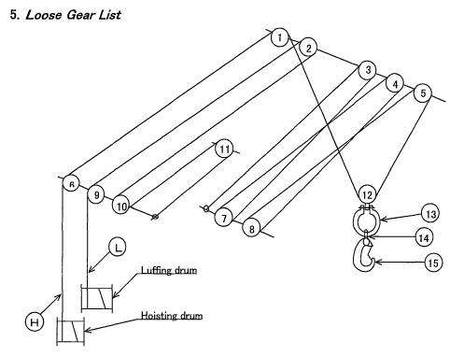
Jib top sheaves
Post top sheaves
6

Crane No. 1 Jib Top Sheaves
1) Crane No. 1 Jib Top Sheaves
Hoisting Wire: 33.5 mmØ
Wear limit: 8.0mm
Wear:

2) Crane No. 1 Jib Top Sheaves
Luffing Wire: 28.0 mmØ
Wear limit: 7.0mm
Wear:

3) Crane No. 1 Jib Top Sheaves
Hoisting Wire: 33.5 mmØ
Wear limit: 8.0mm
Wear:

Crane No. 1 Jib Top Sheaves
4) Crane No. 1 Housing Top Sheaves
Hoisting Wire: 33.5 mmØ
Wear limit: 8.0mm
Wear:

5) Crane No. 1 Housing Top Sheaves
Hoisting Wire: 33.5 mmØ
Wear limit: 8.0mm
Wear:

Crane No. 1 Post Top Sheaves
6) Crane No. 1 Post Top Sheaves
Hoisting Wire: 33.5 mmØ
Wear limit: 8.0mm
Wear:

9) Crane No. 1 Post Top Sheaves
Luffing Wire: 28.0 mmØ
Wear limit: 7.0mm
Wear:

10) Crane No. 1 Post Top Sheaves
Luffing Wire: 28.0 mmØ
Wear limit: 7.0mm
Wear:

Crane No. 1 Post Top Sheaves
Fitted on jib mid section – wear down to check during drydock | 11) Crane No. 1 Post Top Sheaves  Luffing Wire: 28.0 mmØ  Wear limit: 7.0mm  Wear:
7) Crane No. 1 Post Top Sheaves
Hoisting Wire: 33.5 mmØ
Wear limit: 8.0mm
Wear:

8) Crane No. 1 Post Top Sheaves
Hoisting Wire: 33.5 mmØ
Wear limit: 8.0mm
Wear:

